الجمهورية اللبنانية
الاسم والشهرة:--------------------

رقم المرشح :----------------------
وزارة التربية والتعليم العالي الامتحانات الرسمية لشهادة الامتياز الفني
المديرية العامة للتعليم المهني والتقني لدورة عام 2015 الاولى
===============
الاختصاص والرمز : المعلوماتية الادارية ( 23104)
المادة : برمجة ويب Web المعدل: (10)
المستندات المسموح بها : لا شيء المدة : ساعتان

- Choose the right answer : (1 ½ pts)
- The object that store data locally in the navigator without expiry date is :
- webStorage b- localStorage c- sessionStorage d- Cache section
- The method that retrieves the actual geographical location is:
- getCurrentPosition() b- coords.latitude c- coords.longitude d- geolocation
- When executing a script in HTML page, the page becomes unresponsive until the script is finished, to solve this problem we must use:
- Cache application b- Web Worker c- WebStorage d- drag & drop
- To make an element movable with drag and drop, we use:
- allowDrop(event) b- draggable="true" c- drop(event) d-ondragstart=”true”
- The text file which indicates to the browser what it must put in cache is the:
- Manifest file b- HTML file c- Javascript file d- Batch file
- In Javascript, the method that allows the data entry from a keyboard is:
- alert() b-confirm() c- prompt() d- document.write()

- Write the appropriate HTML5 and JAVASCRIPT tags to obtain as result the following page, that calculate the total price of a product,while respecting the following conditions: (4 pts)
- « Product name » Entry Field of 24 characters. This field cannot be empty; the test should be done according to a function when we click outside the field.
- « Product price » Entry Field of 24 characters. This field must contain a value between 10 and 20; the test should be done according to a function when we click outside the field.
- « Product quantity » Entry Field of 24 characters. This field must contain a value greater than 0; the test should be done according to a function when we click outside the field.
- « T.V.A » a Checkbox field.
- « Show » a button that executes a function that calculates and displays the total in a message box as shown in the form bellow.
The total is calculated according to the condition: if T.V.A is checked then the total = price* quantity *1.1 ,
if not then the total = price* quantity.

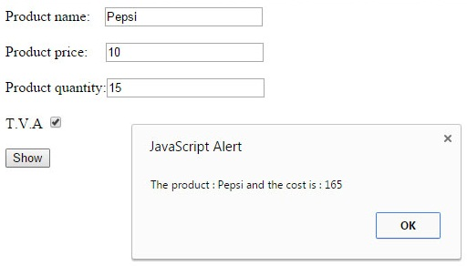
- Write the appropriate HTML5 tags and the appropriate CSS properties to obtain as result the following page: (4 pts)
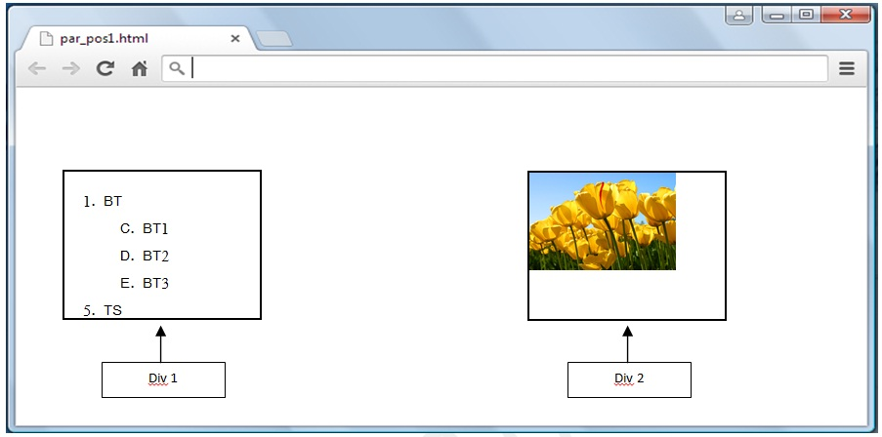
- This page contains 2 divisions (Div 1, Div 2).
- Each division has the following characteristics:
Width: 200 pixels. Height: 150 pixels. Border type: solid. Border thickness: 2 pixels.
- The first division contains an ordered list.
- The second division contains an image "tulips.jpg" having the following dimensions: Width:100 pixels; Height:75 pixels.
- The layout of the 2 divisions should be done by using one of the 2 following methods (absolute position or inline-block). The characteristics of each method are shown in the below table:

الاختصاص والرمز : المعلوماتية الادارية ( 23104) المادة : برمجة ويب Web
 | Div1 | Div2
Absolute position | Position: absolute, 100 pixels from top of the page and 20 pixels from the left of the page. | Position: absolute, 100 pixels from top of the page and 400 pixels from the left of the page.
Inline-block | Top margin: 100 pixels.  Left margin: 20 pixels. | Left margin: 180 pixels.
- Write the appropriate HTML5 tags to obtain the following page : (4 pts)
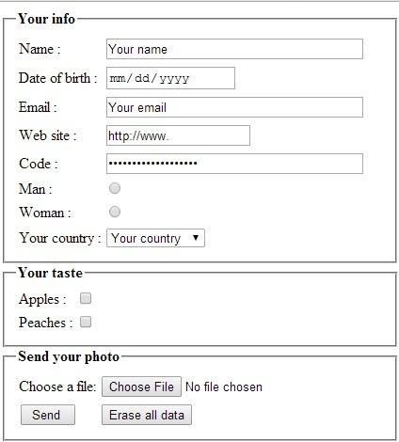
- Name: Input field, 40 visible characters, and maximum 256 characters.
- Indicate the appropriate type for the following fields: Date of birth, Email, Web site, Code.
- Man / Woman: Radio button only one choice is acceptable.
- Your country: Combobox that contains the following values : "France, Canada, Lebanon, Others"
- Apples / Peaches: Checkbox, many choices are acceptable.
- Choose a file: Input field of type file.
- A button Send to send data to: "www.mysite.com/select.php" using the post method.
- A button Erase all data to return the document to the initial state as shown above.

- By using "SVG" or "Canvas", write the appropriate HTML5 tags to draw the rectangle in the following page: (2 ½ pts)
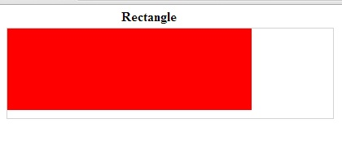
The rectangle characteristics are the following:
- Width: 300 pixels - Height: 100 pixels - The left position of the rectangle: 0 - The top position of the rectangle: 0
- The rectangle color is: red. (Use rgb, rgba or hexadecimal code)

- Write the appropriate HTML5 tags and the appropriate CSS properties to obtain as result the following page: (4 pts)
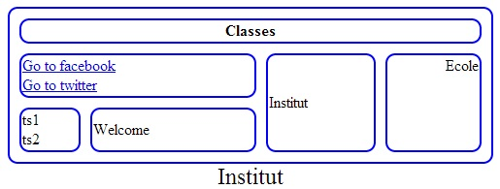
- The table title is: "Institut", the title size is : 24 pixels aligned at the bottom center of the table.
- The table has the following characteristics:
- Width: 500 pixels - Height: 50 pixels - Space between borders: 10 pixels - Round borders: 10 pixels
- The table and cells border thickness is 2 pixels, the color of the border is blue. (Use rgb, rgba or hexadecimal code)
- 2 external links: www.facebook.com and www.twitter.com .

